**Development Documentation Haukainga HomeWinds**

**Business Application Programming**

**Part 3: Software Development**

*Michael Amann, Talgat Narbaev, Lukas Weitzer*

Date: 9 Oct 2023

First draft – added Lukas parts (ex

**Table of Content:**

**1**  **Introduction** 3

**2**  **Property Management** 3

**2.1**  **Setting up** 3

**2.1.1**  **Categories** 3

**2.1.2**  **Amenities** 4

**2.1.3**  **Services** 5

**2.1.4**  **Attributes** 5

**2.1.5**  **Bed Types** 6

**2.1.6**  **Seasons** 6

**2.1.7**  **Rates** 7

**2.2**  **Create a Property** 8

**3**  **Booking Management** 10

**3.1** **Setting up** 10

**3.1.1**  **Booking Rules** 10

**3.1.2**  **Taxes and Fees** 11

**3.1.3**  **Coupons** 12

**3.1.4**  **Booking Settings** 12

**3.1.5**  **Payment Gateways** 13

**3.2**  **Placing Bookings** 14

**3.3**  **Manage Bookings** 16

**4**  **User Management** 18

**4.1**  **User Login** 18

**4.2**  **User Registration** 19

**4.3**  **Property Owner Role** 21

**5**  **Additional Features** 23

**5.1**  **WP Mail SMTP** 23

**5.2**  **WP Forms** 24

**5.3**  **Sending Emails** 24

**6**  **User Acceptance Testing** 25

# **1 Introduction**

This documentation provides descriptions of website usage, settings set up managements in detailed version for project supervisor and client. As the development team we will go through each page, function, permissions, roles and settings in Haukainga HomeWinds website. Addition to that this documentation has brief explanation of every plugin used in project and its purpose. However, many features can be added or upgraded by premium versions of certain plugins and this documentation will guide the client throughout the project and understand the functionality of website.

# **2 Property Management**

Property Management consists of various tasks. In this section, we will set up the necessary elements to add a new property to the website.

## **2.1 Setting up**

### **2.1.1 Categories**

Navigate to Accommodation/Categories (Figure 1). New Categories can be added to give the customer more information about the property. We decided to add location information into the categories, but it is not limited to it (Figure 2). Categories will be available for selection in the creation of a new property. Categories can be added by administrators as well as property owners.

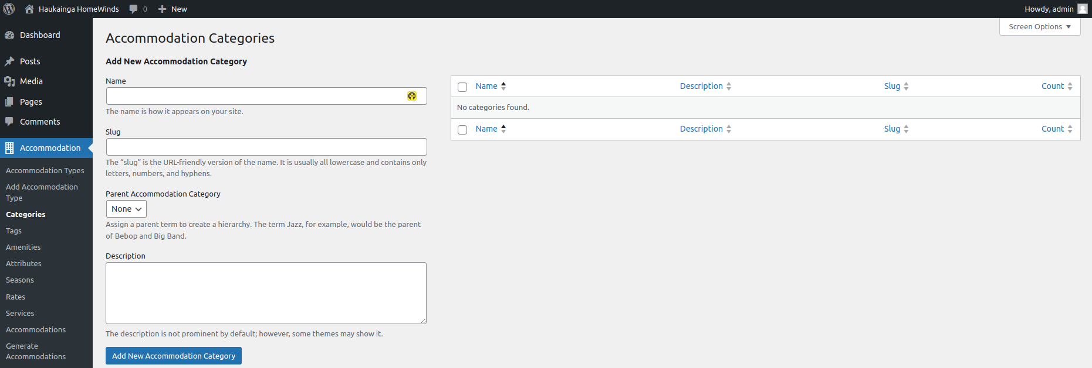

*Figure 1: Add new Categories*

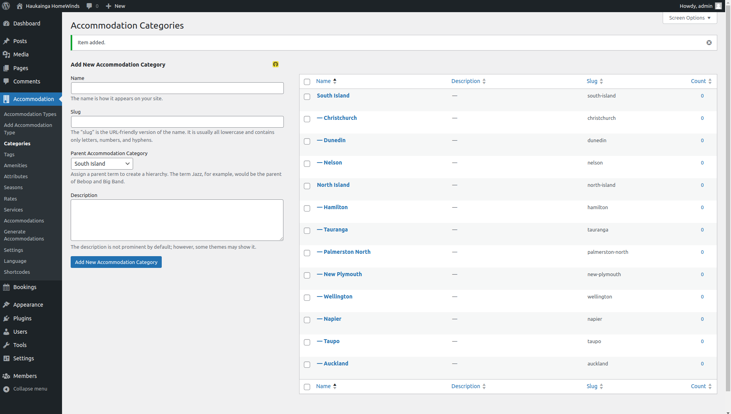

*Figure 2: Locations added*

### **2.1.2 Amenities**

### 

Navigate to Accommodation/Amenities (Figure 3). In this part, we will add amenities and possible features that can be selected during the creation of a new property. We decided to add information about the rooms as well as general amenities that could be of value to customers (Figure 4). Amenities can be added by administrators and property owners.

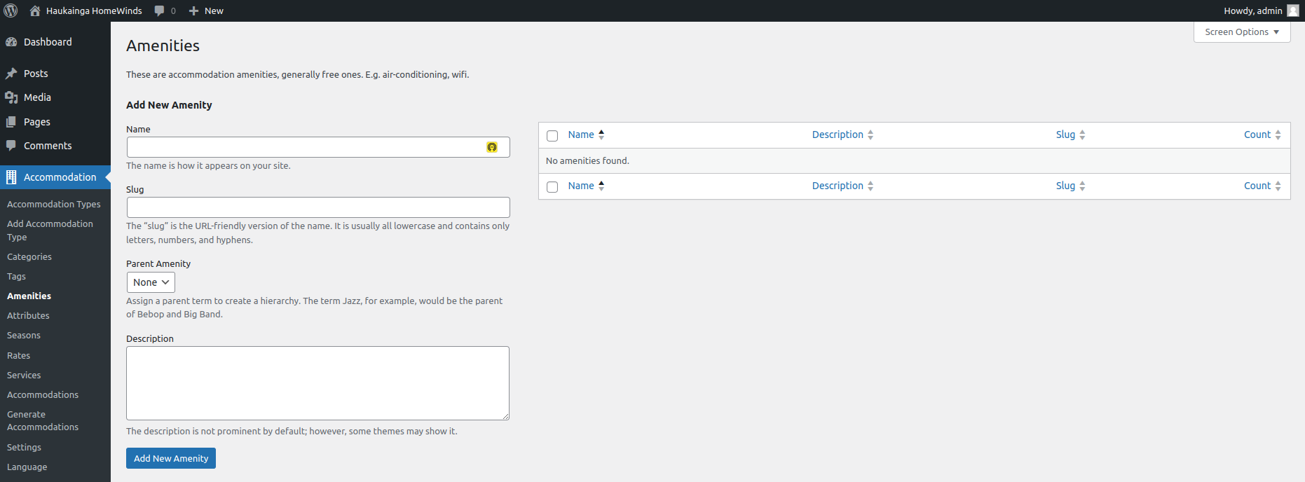

*Figure 3: Adding Amenities*

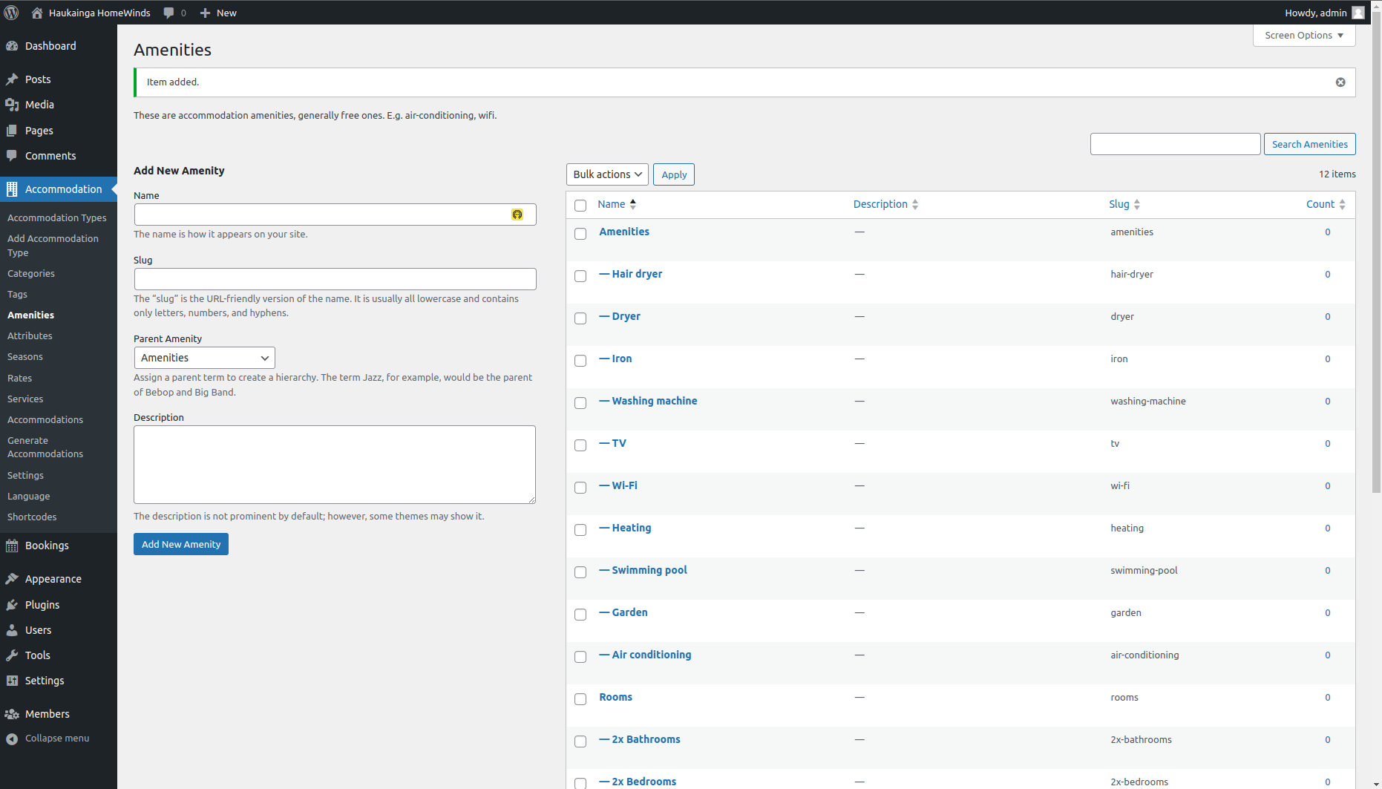

*Figure 4: Amenities added*

### **2.1.3 Services**

Navigate to Accommodation/Services (Figure 5). The client stated that there might be collaborations with other businesses and service providers in the future. Services allow the property owners to add these third-party features and adjust pricing and rates. Because this feature is not in use at the current stage, we did not include services during development. Services can be selected during the creation of a property. Services also include a page with additional information that can be customized by using “Elementor” or the WordPress page editor.

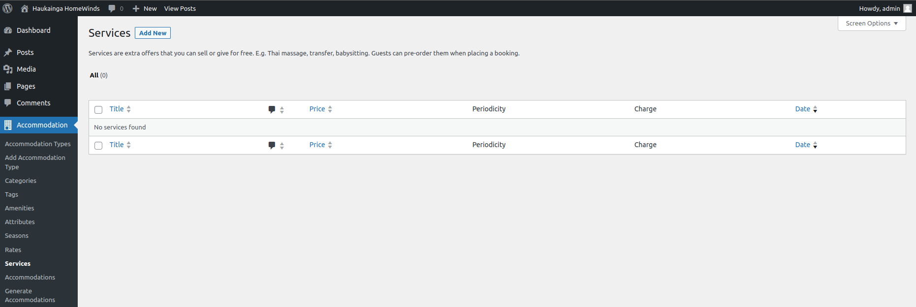

*Figure 5: Adding Services*

### **2.1.4 Attributes**

Navigate to Accommodation/Attributes (Figure 6). This is a “Pro” feature of the Hotel Booking Plugin. We encourage the client to invest in these features. Attributes allow more detail than categories. Search functionalities also get extended and will be beneficial for the user experience.

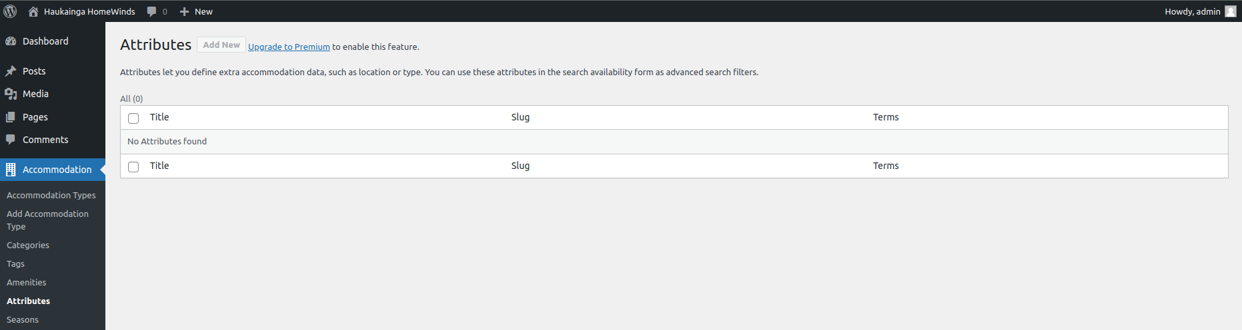

*Figure 6: Adding new Attributes*

### **2.1.5 Bed Types**

Navigate to Accommodations/Settings/General => Misc # (Figure 7). Here we can add different types of beds that will be available to add to a property.

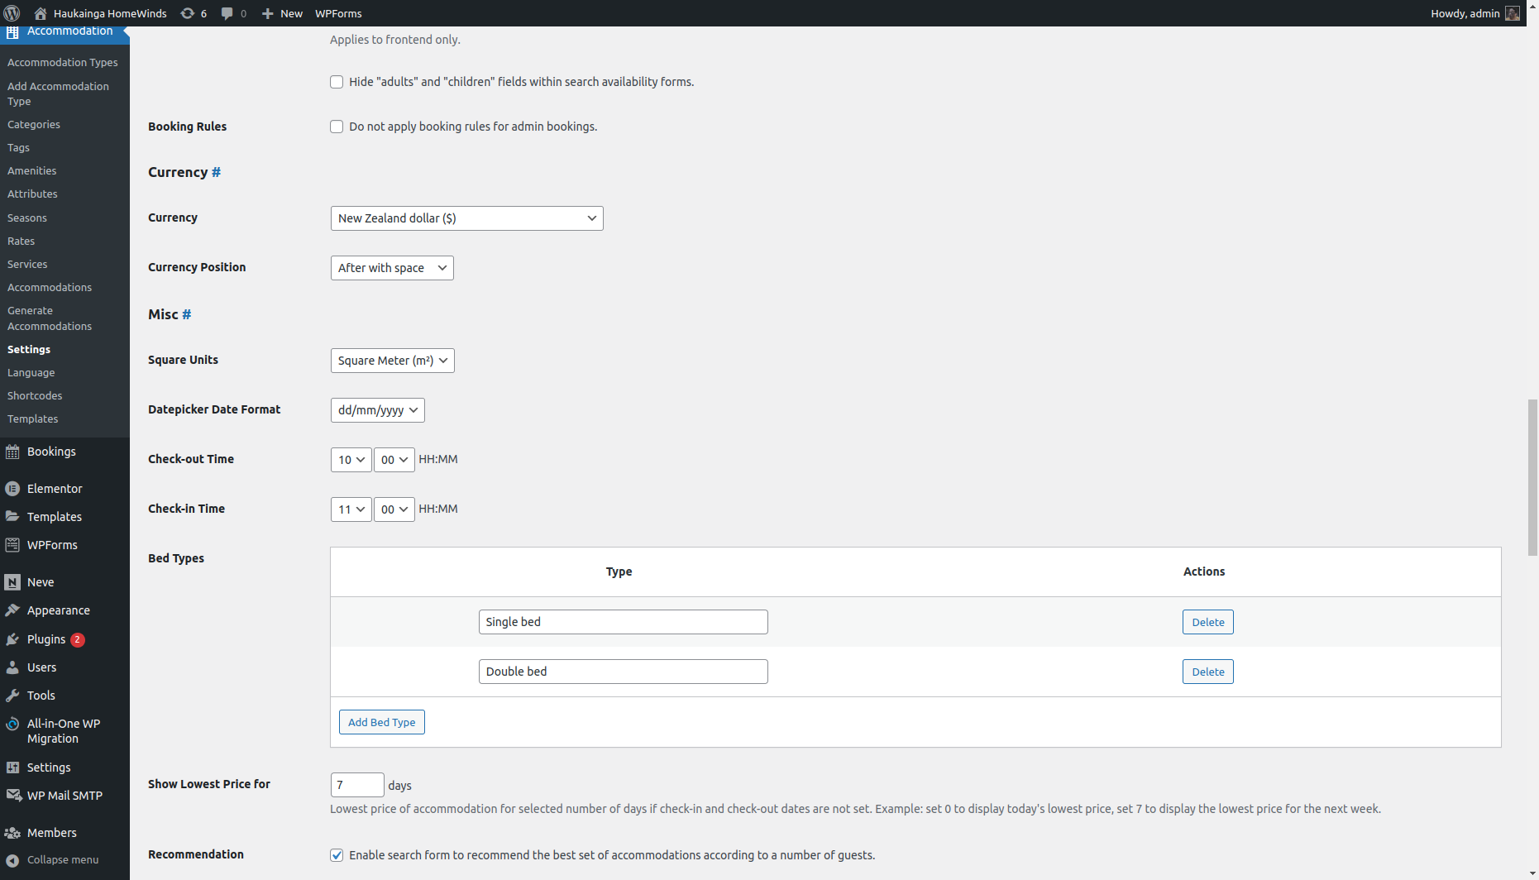

*Figure 7: Adding Bed Types*

### **2.1.6 Seasons**

Navigate to Accommodation/Seasons (Figure 8). As stated by the client, the website should include features for seasonal pricing. New seasons can be added by selecting start and end dates as well as applying seasonal prices only for specified days (Figure 9). This could also be used to implement special prices for public holidays. Seasons will be available to set the prices for the properties (Figure 10).

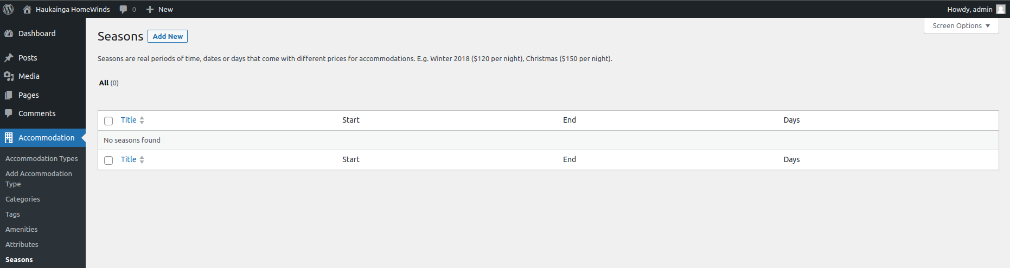

*Figure 8: Adding New Seasons*

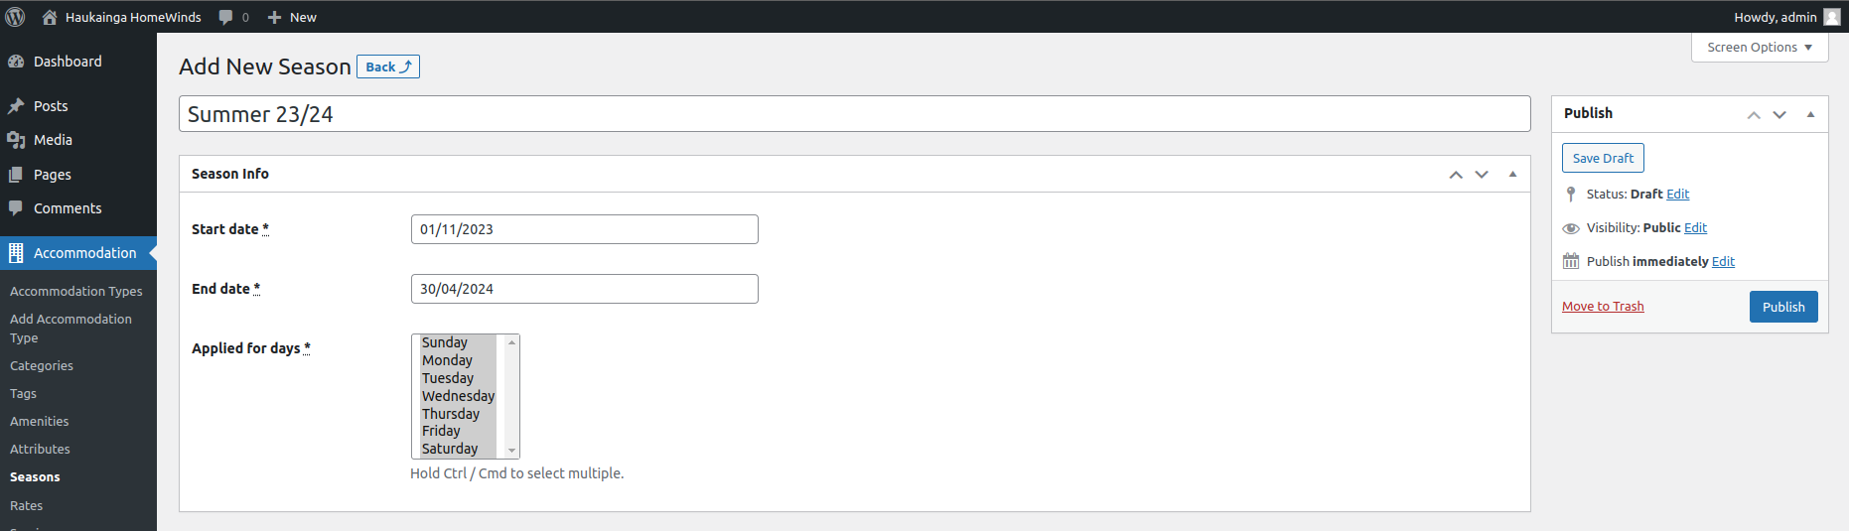

*Figure 9: Configuring a new Season*

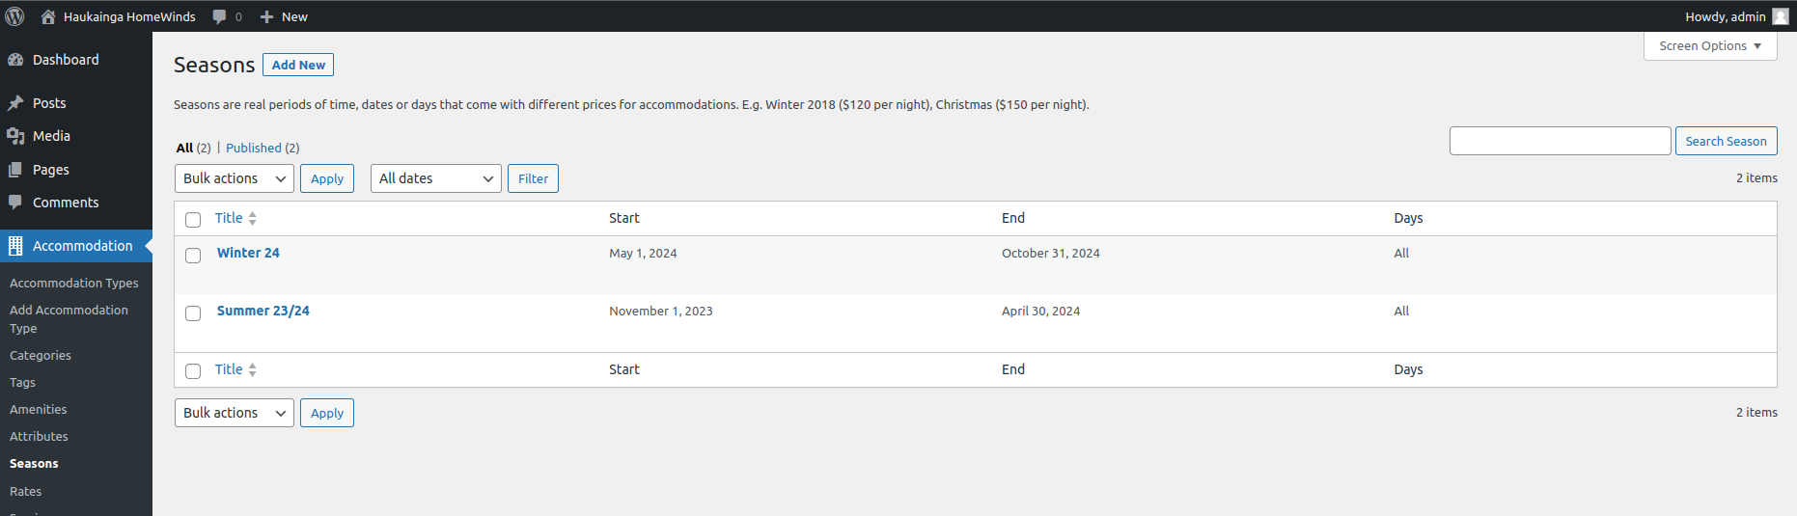

*Figure 10: Seasons added*

### **2.1.7 Rates**

Navigate to Accommodation/Rates (Figure 11). Rates can be used to add different prices based on the previously created seasons (Figure 12). Multiple rates can be added to also include special features or partial renting.

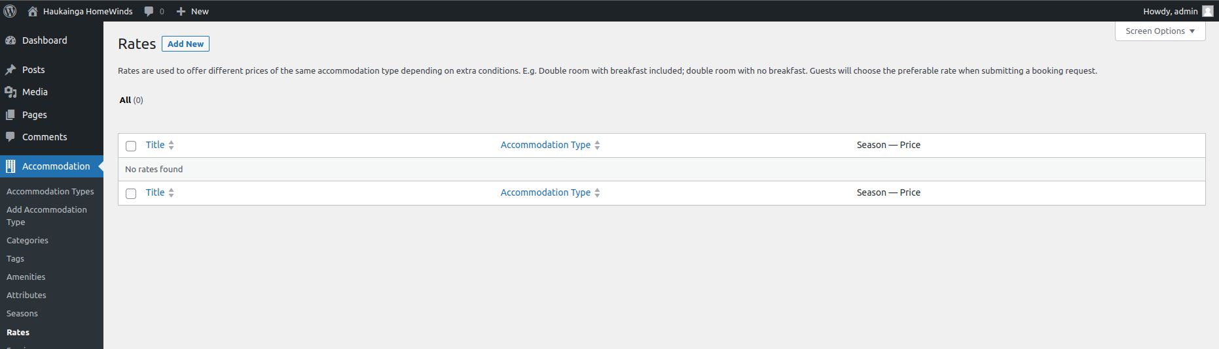

*Figure 11: Adding Rates*

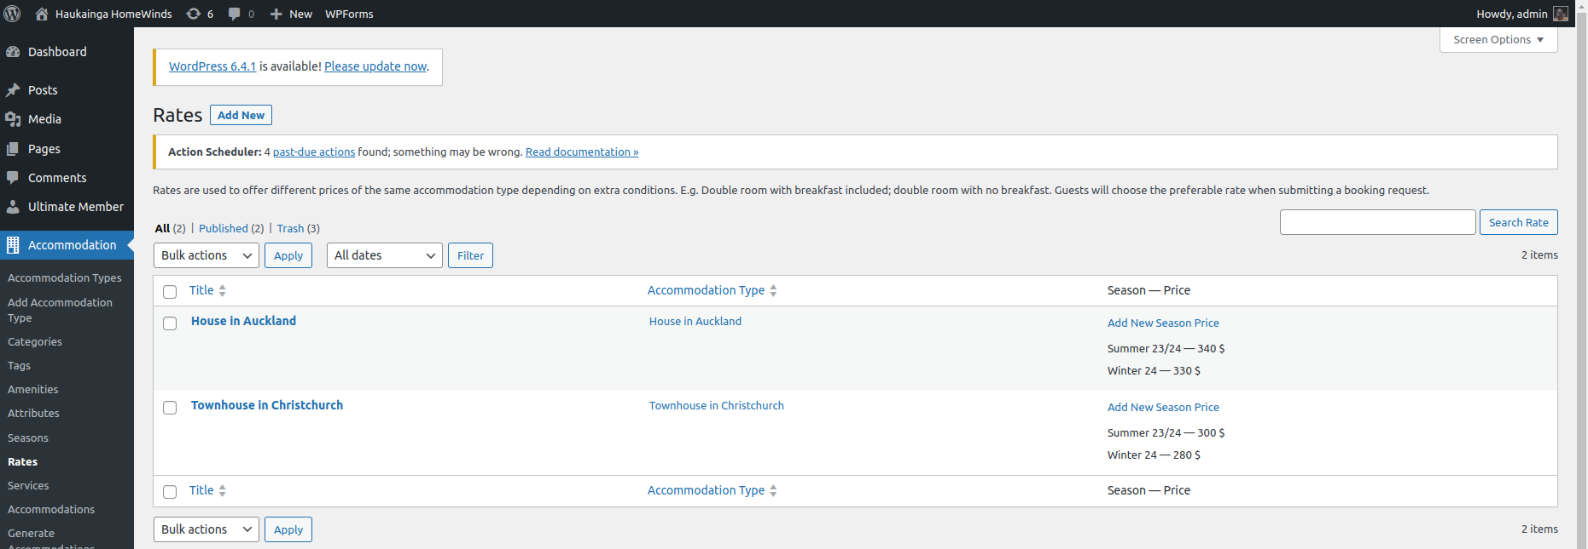

*Figure 12: Rates added*

## **2.2 Create a Property**

After the setup, we are now able to create a new property entry. Properties can be added, edited, and deleted by administrators or the property owner.

Navigate to Accommodation/Accommodation Types (Figure 13).

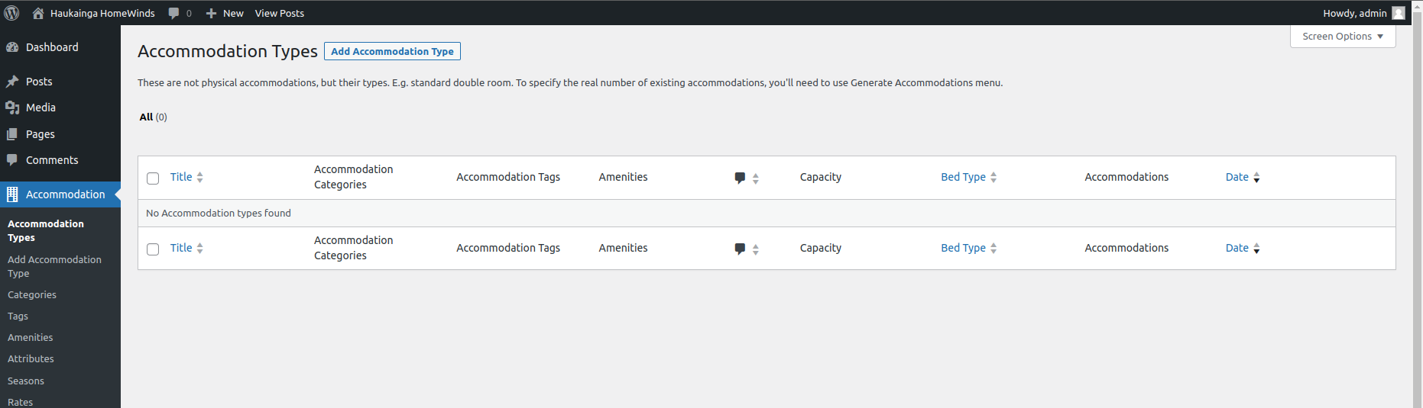

*Figure 13: Adding a new Property*

The property owner can use the WordPress editor to customize his property and include various “Blocks” to include media, descriptions, and a map showing the location (Figure 14).

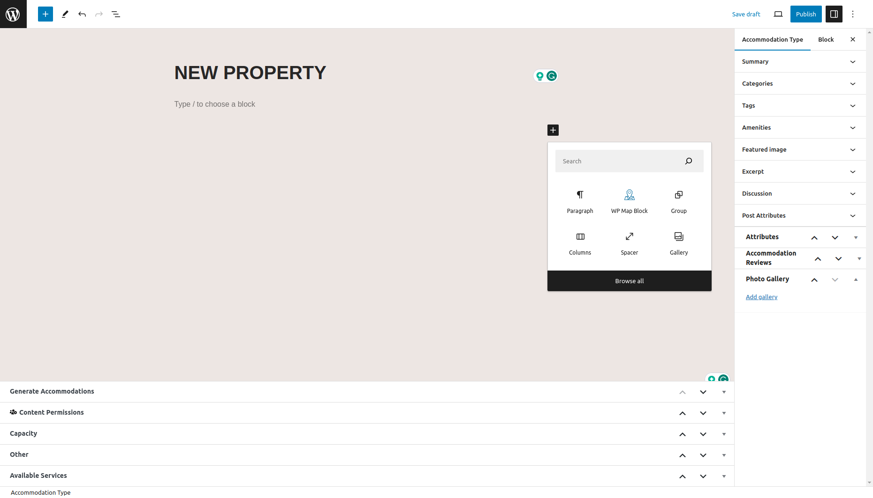

*Figure 14: Property Editor*

On the menu on the right side of the screen, you can add the previously created Categories, Amenities, and Attributes. A Feature image and excerpt can be added that gets displayed while the user is browsing through the property listings. Comments can be enabled in the Discussion tab. When using the “Pro” version of the Hotel Booking Plugin, the review and rating functionalities can be enabled. A photo gallery can be added to include more images showcasing the property.

The menu on the bottom of the screen allows the property owner to set the capacity of the property, adding “View” tags to give more details about the location. The bed type can be selected. These get added in Accommodation/Settings. Services can be added.

“Generate Accommodations” must be set to 1. A property only exists once, but this functionality can be used for listing rooms or multiple houses with the same specifications.

The client requested a map feature to be available to add to the properties. This can be achieved by adding a WordPress Map Block. Navigating to the Block settings on the right allows the property owner to change the marker location (Figure 15). The size and placement of the map can be easily adjusted using the Editor.

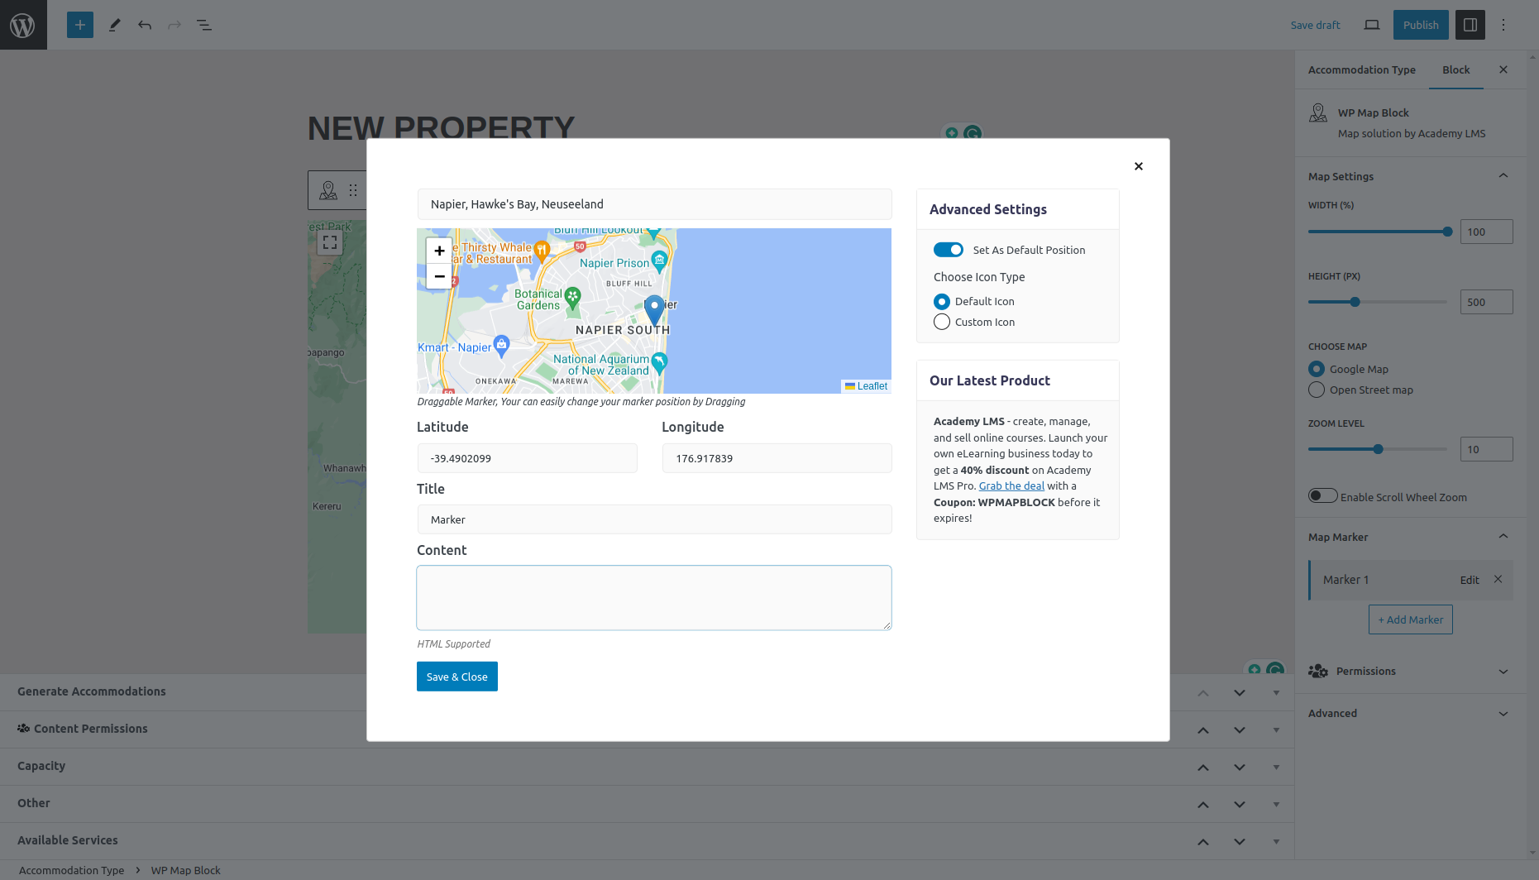

*Figure 15: Adding a map*

To finish the creation of the property we can publish the site at the top right of the screen. The Property is now available at the site. To make it bookable we will continue with the booking management guide.

# **3 Booking Management**

After adding a property to the website, we can continue managing the bookings.

In this guide, we will look at different settings and options to allow and manage bookings of properties.

## **Setting up**

### **3.1.1 Booking Rules**

Navigate to Bookings/Booking Rules (Figure 16). Here we can add several rules that get applied for booking the properties. The property owner can edit check-in/out times and minimum/maximum stay times. Blocking, buffering, and rules for booking in advance offer extended management options.

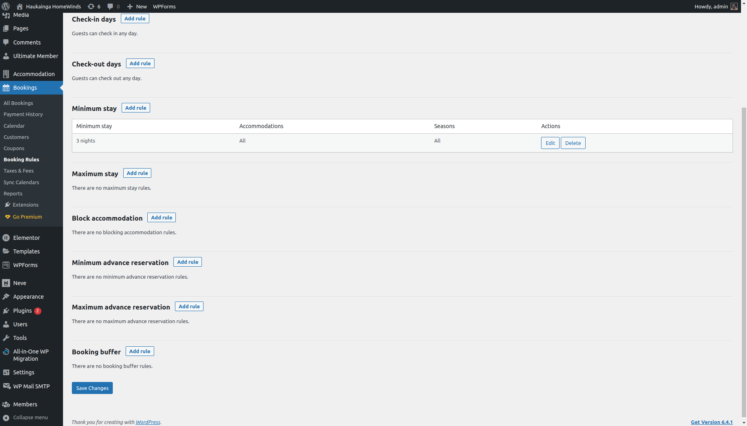

*Figure 16: Adding Booking Rules*

### **3.1.2 Taxes and Fees**

Navigate to Bookings/Taxes and Fees (Figure 17). There are multiple options to add additional taxes and fees.

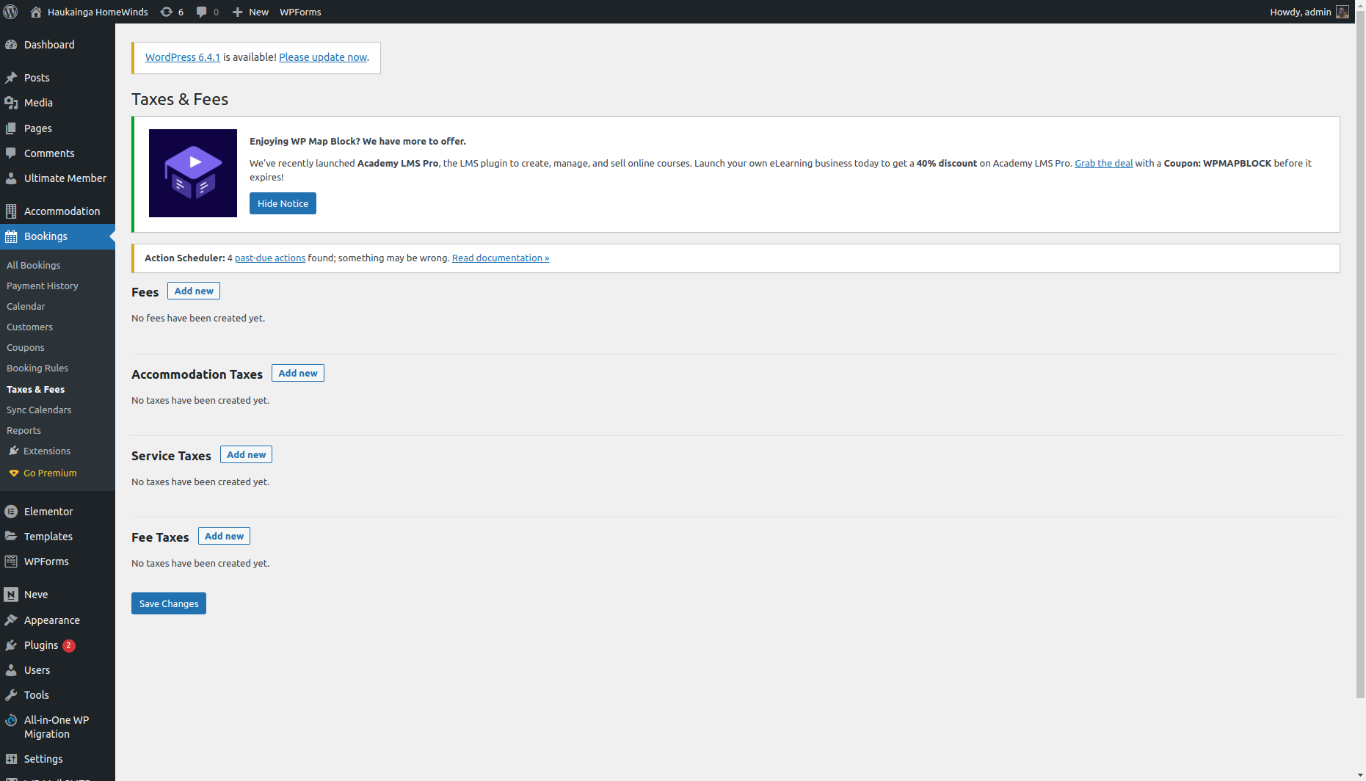

*Figure 17: Adding Taxes and Fees*

### **3.1.3 Coupons**

Navigate to Bookings/Coupons (Figure 18). Property owners might want to offer special discounts or coupons for advertisement reasons. Coupons can be configured in various ways to match the requirements of the property owner (Figure 19).

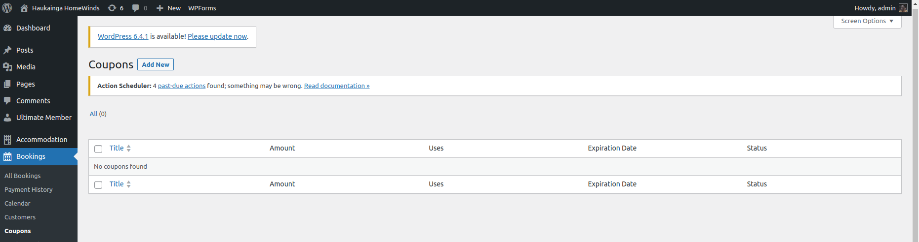

*Figure 18: Adding Coupons*

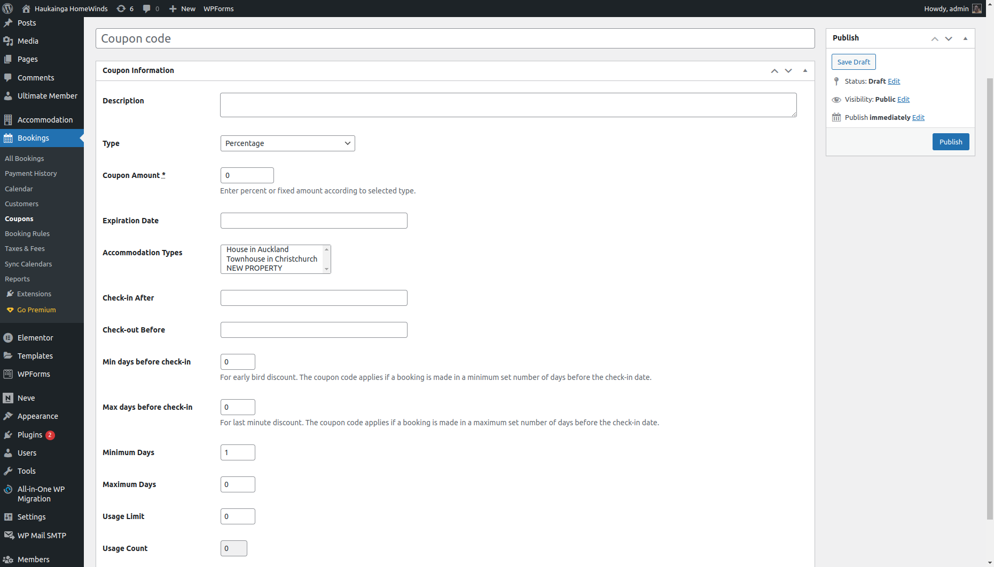

*Figure 19: Creating a Coupon code*

### **3.1.4 Booking Settings**

Navigate to Accommodation/Settings/General. Here multiple Booking related settings can be adjusted. Currency, country settings, and redirection pages (Figure 20). We adjusted the setting suitable for our development and testing phases. We encourage the client to alter these settings to match the requirements.

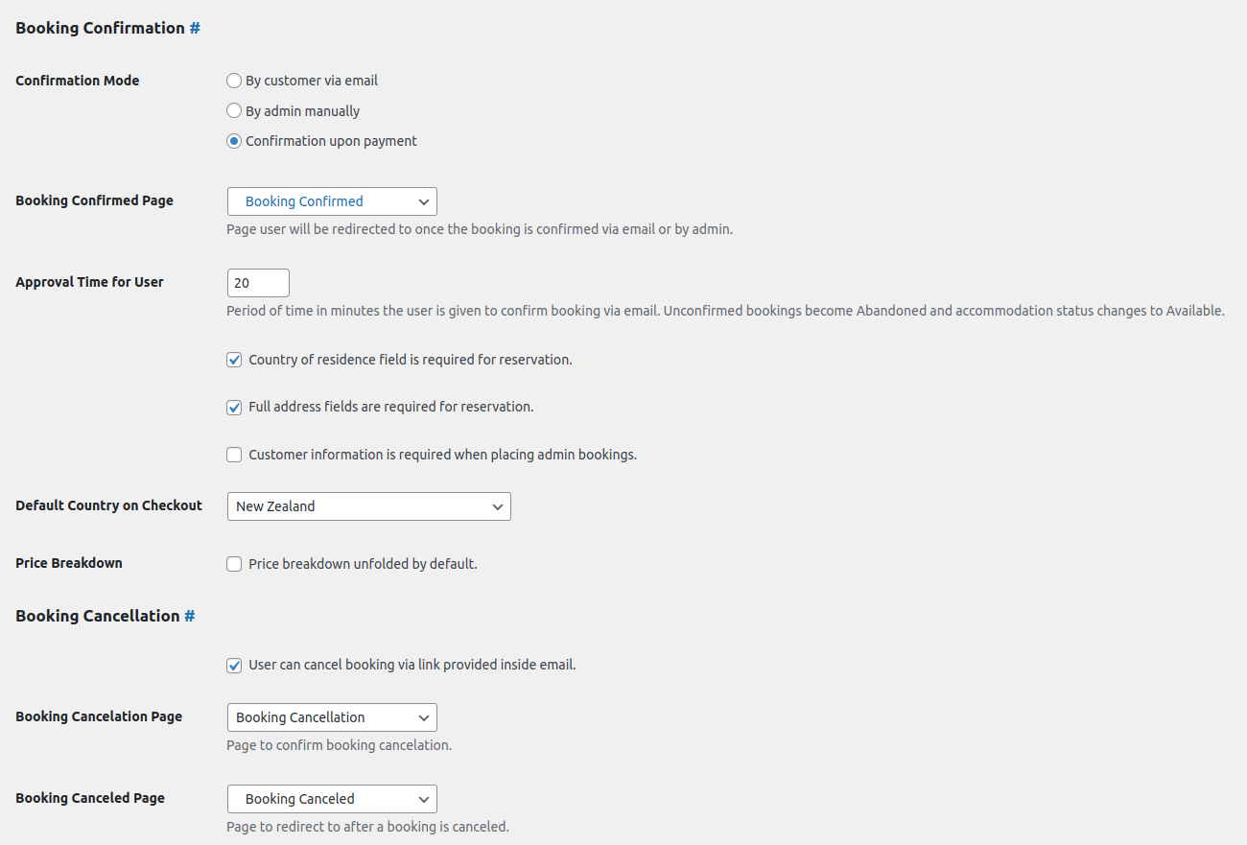

*Figure 20: Booking Settings*

### **3.1.5 Payment Gateways**

Navigate to Accommodation/Settings/Payment Gateways. Firstly, you will be sent to General Settings (Figure 21), where you can adjust some payment parameters such as payment type (Deposit/Fixed), payment time, some payment related pages directions, default gateway and payment pending time. The client can adjust all those settings according to their preferences.

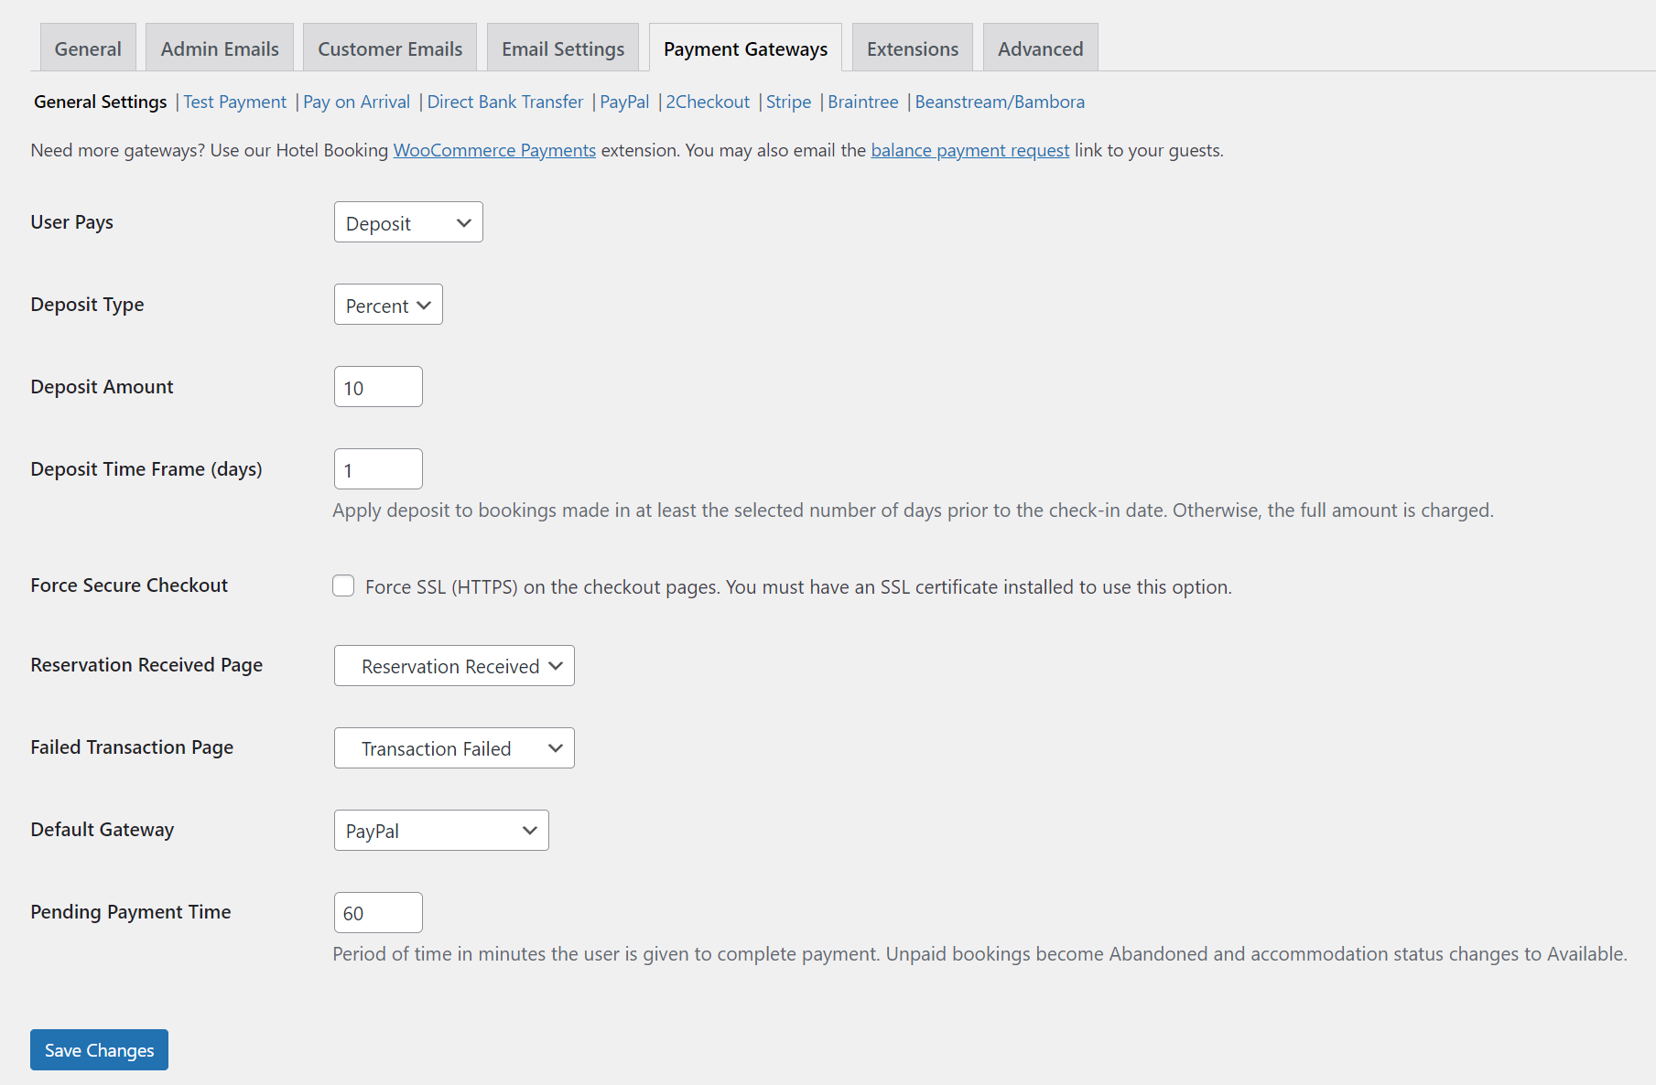

*Figure 21: Payment Gateways General Settings*

Under the main settings option above you will have sub menu of payment gateways below in blue colour, where you can navigate throw all the payment options and set each individually. For current stage of project, we only set up Pay on Arrival and Direct Bank Transfer only. However, PayPal option could be added as well, but after some research we found that it requires PayPal business account and Refence Payment option enabled through contacting PayPal Support Team. Moreover, there are plenty of other payment options, which can be added by upgrading the Hotel Booking Lite plugin to premium version. As it has been said above, it all be added by client preferences for payment gateways. As example you can see the PayPal gateway setting (Figure 22), where you will need to add your PayPal business account email address.

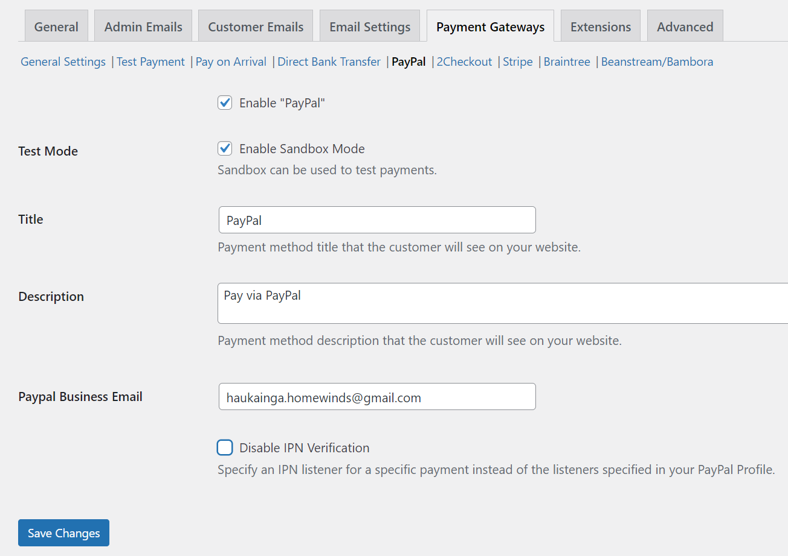

*Figure 22: Paypal Gateway Settings*

## **3.2 Placing Bookings**

After setting up the property and booking information, we can start placing bookings.

To place a booking, we need an account. Please refer to …. to see how to create an account or log into an already existing account.

Navigate to a property to place a booking. At the bottom of the property entry, we find the availability calendar and a reservation form (Figure 23). After selecting Check-in/out dates we can place a reservation (Figure 24).

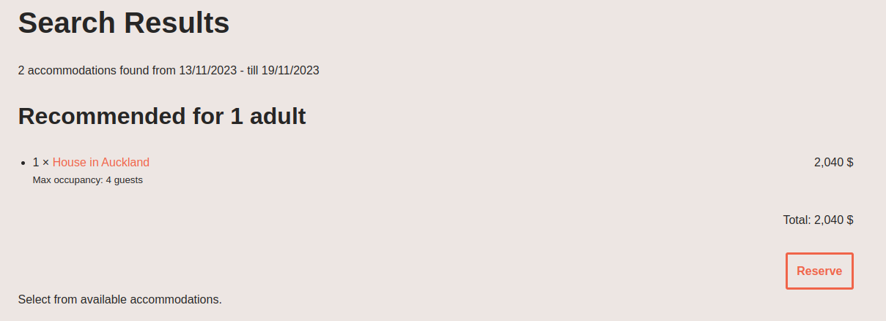

*Figure 23: Reserve*

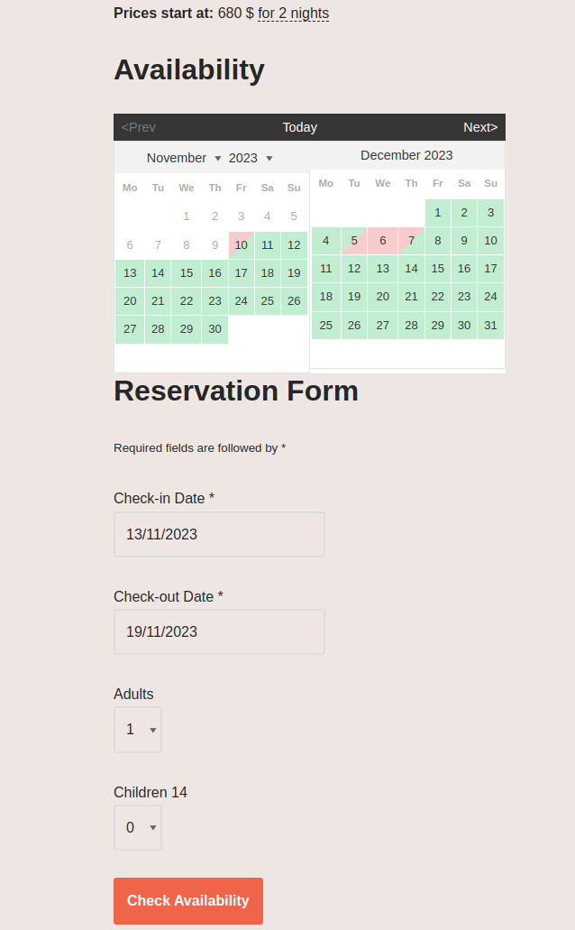

*Figure 24: Check Availability*

You will be asked to enter relevant personal information, select a payment method, and accept the terms & conditions (Figure 25). By pressing “Book Now” the booking gets placed and the user gets redirected to the “Reservation Received” page as well as an e-mail notification with relevant booking information.

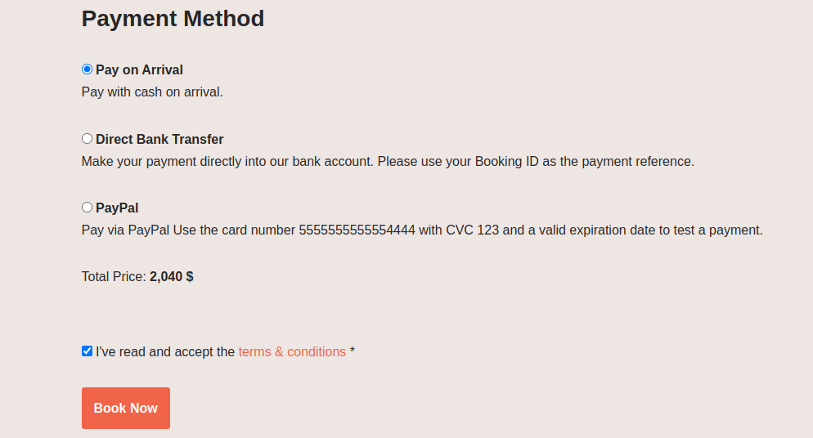

Figure 25: Placing Booking

Depending on the previously chosen settings as well as the payment method the status of payment and booking can be confirmed or on hold (Figure 26).

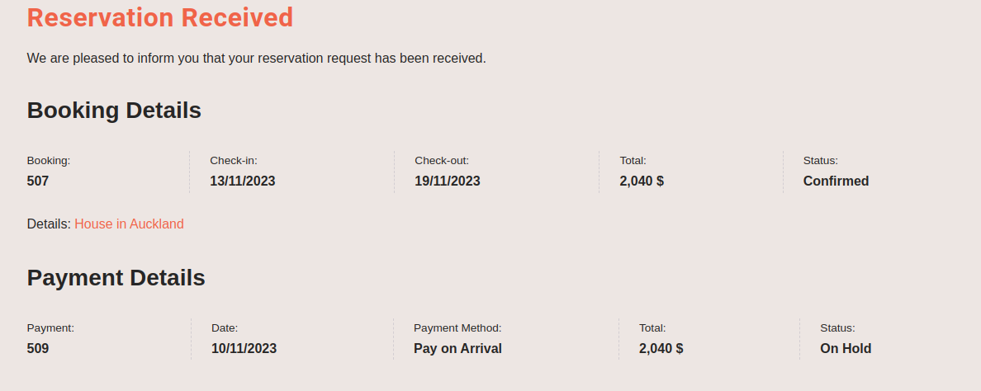

*Figure 26: Reservation Received*

## **3.3 Manage Bookings**

Navigate to Bookings/Calendar (Figure 27). This overview presents all bookings and their status. Booking details can be viewed and payments added manually (Figure 27).

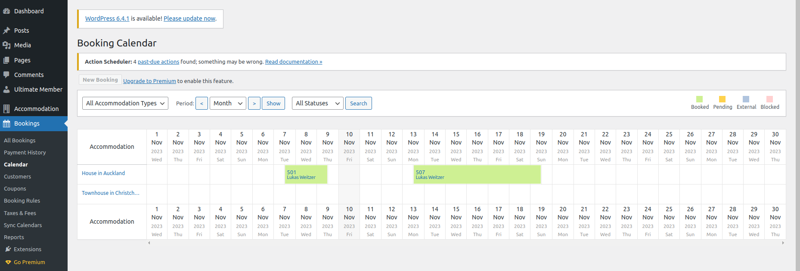

*Figure 27: Booking Calendar*

Bookings can be viewed, edited, and deleted when navigating to Bookings/All Bookings (Figure 28).

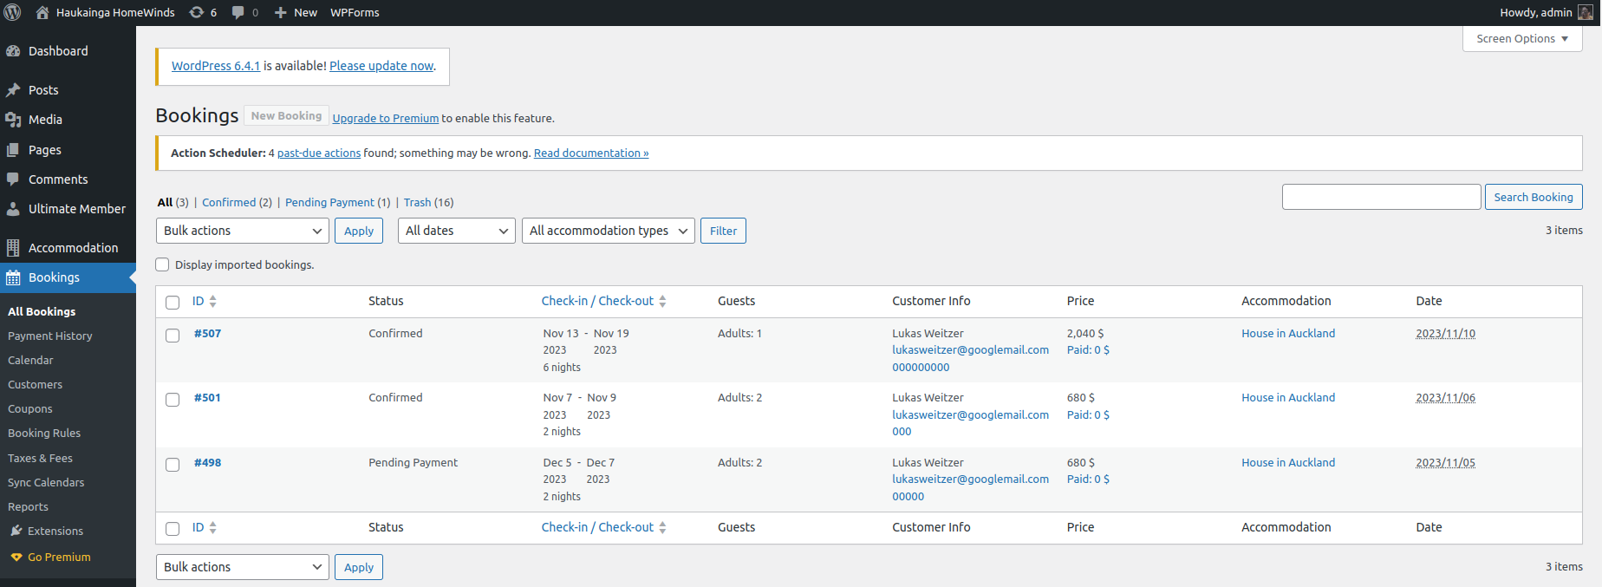

*Figure 28: All Bookings*

Payments can be viewed, edited, and deleted when navigating to Bookings/Payment History (Figure 29).

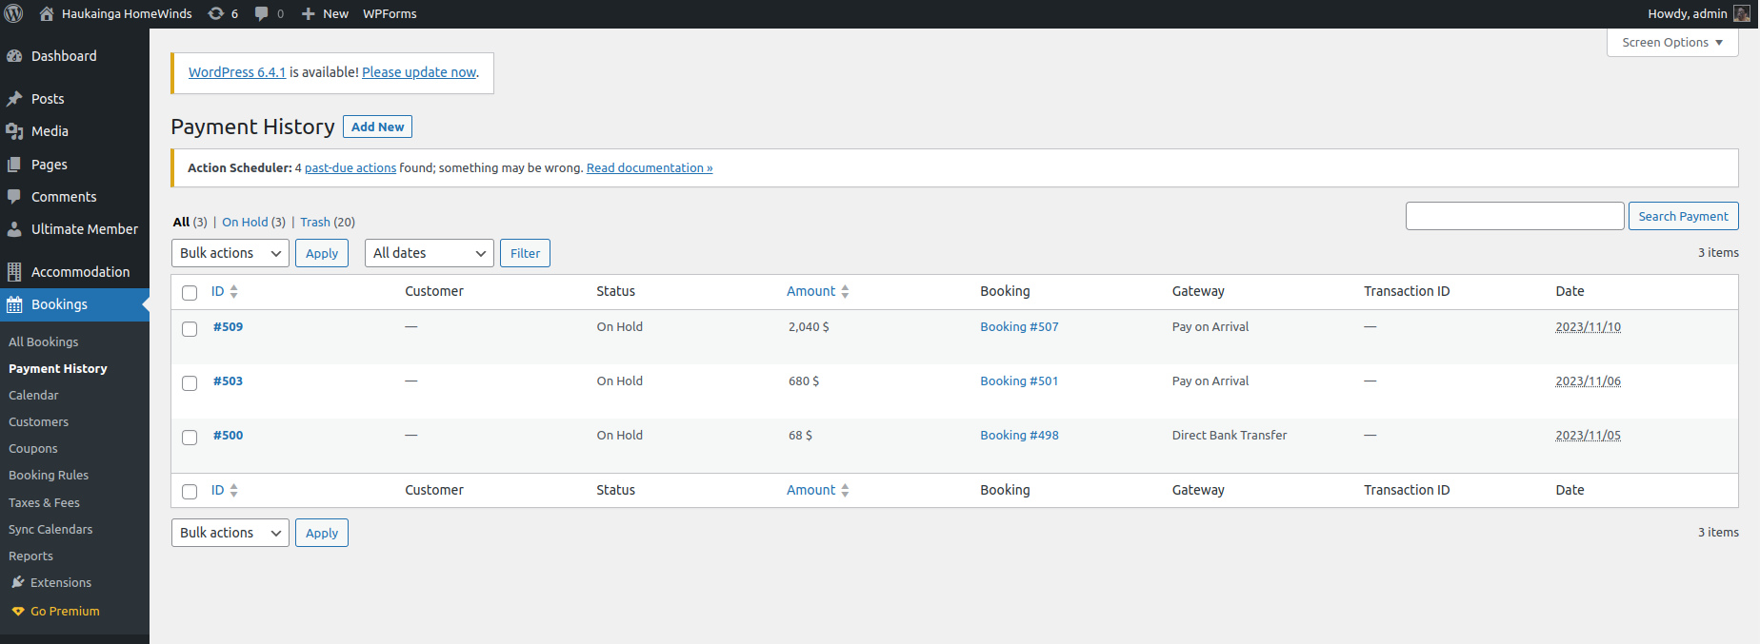

*Figure 29: Payment History*

Navigating to Bookings/Reports displays a report of business activities (Figure 30). When upgrading the Hotel Booking Plugin these results could be exported as a CSV.

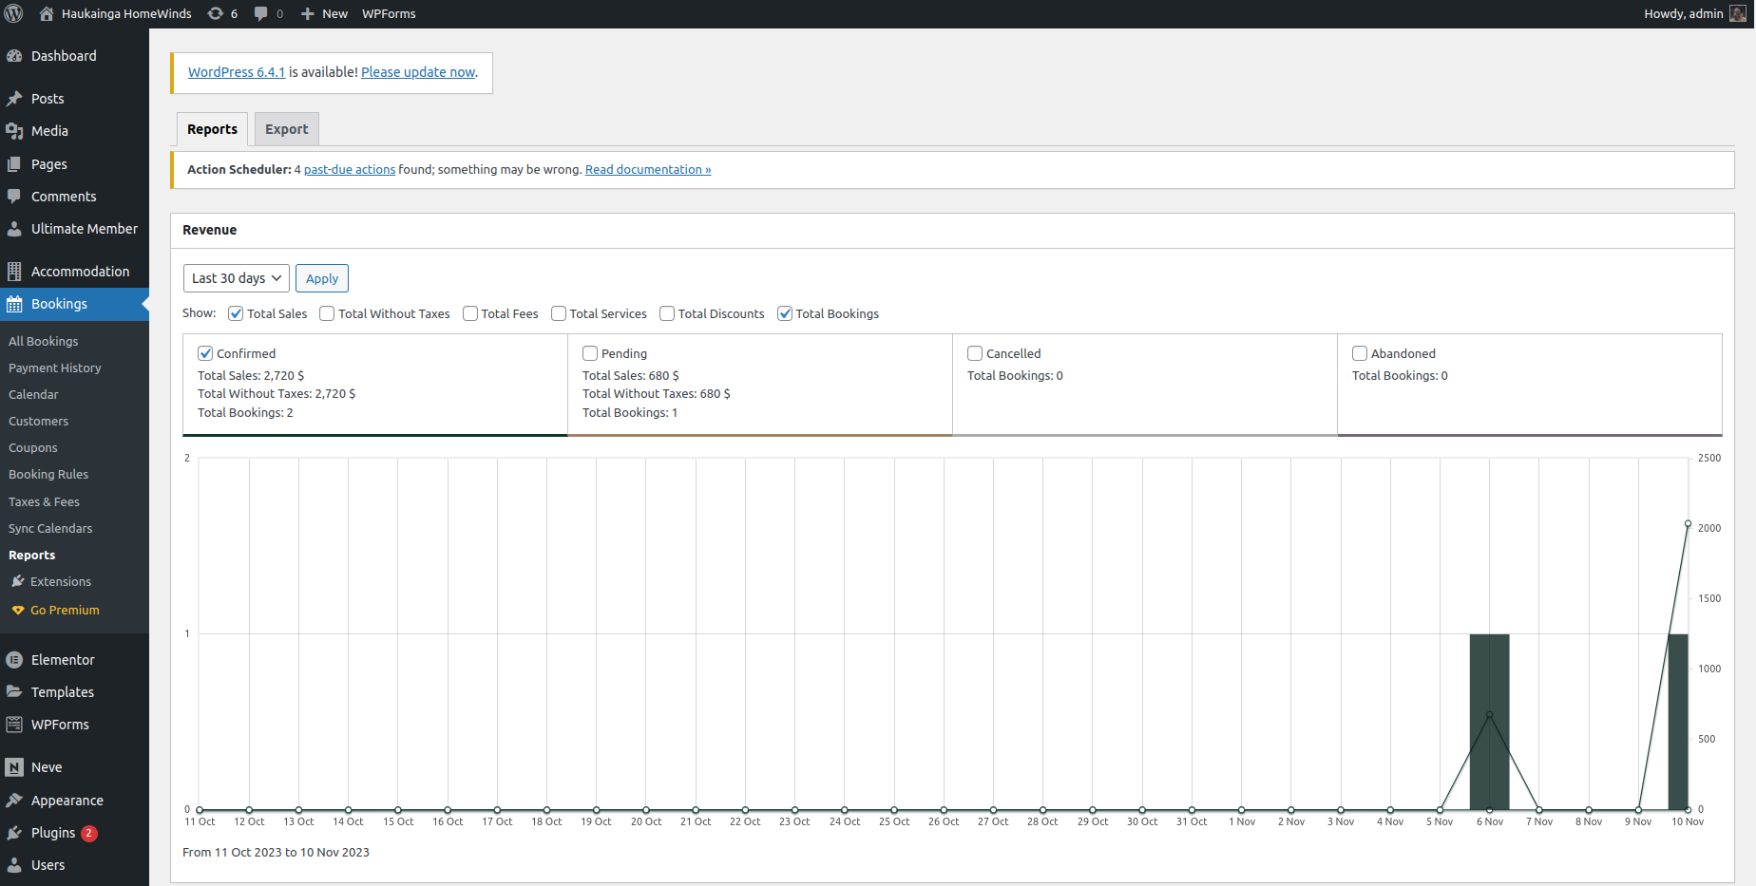

*Figure 30: Reports*

# **4 User Management**

User Management is an essential part of this project because users need an account to make any bookings. There are two options how to gain that permission. Either the user creates a new account, or he/she logs into an existing account. We have implemented two distinct pages to accomplish these operations.

## **4.1 User Login**

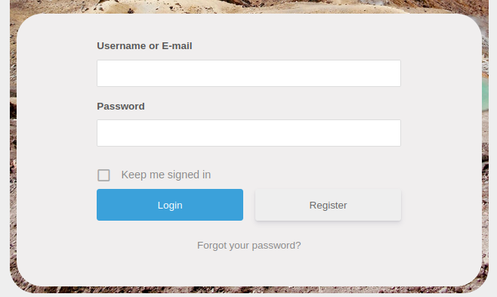

*Figure 31: User Login*

Figure 31 shows the login field, where users with an existing user account can log into their account. Required is the username or email address as well as the password of the account. All these details are determined in the registration process. Users can also reset their passwords in case they forgot it. In this situation, they follow the respective link at the bottom of Figure 31, which redirects them to the page of Figure 32.

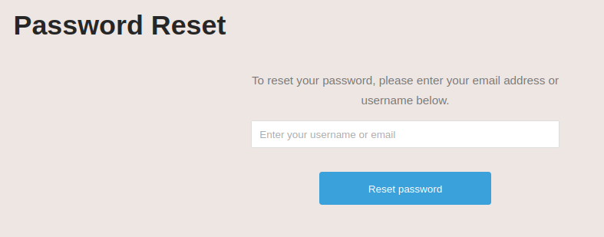

*Figure 32: Reset password*

After inserting the username or email address, an email with instructions to change the password is sent to the user.

After logging into the account, the user is redirected to the account page, where he/she can view and edit the details of the user. On this page, they can also change the password and delete the entire account. This page can be seen in Figure 33.

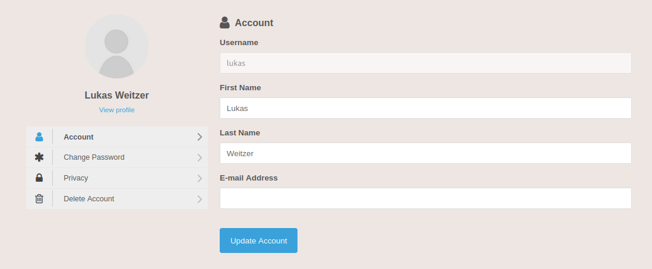

*Figure 33: User account*

Once logged in, the user can start to book properties.

## **4.2 User Registration**

For the user registration, we created a new page which contains all the fields that are needed to generate a new user account. These fields can be seen in Figure 34.

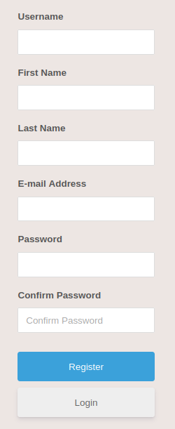

*Figure 34: User Registration*

There are multiple fields that the user must fill in. There are also some rules in place to ensure that accurate data is entered by the user. For example, the user name must be longer than three characters, the email address needs to have a proper structure and password needs to meet certain standards (at least eight characters with numbers, capital and lower case letters). Only when all these criteria are met, then an account can be generated.

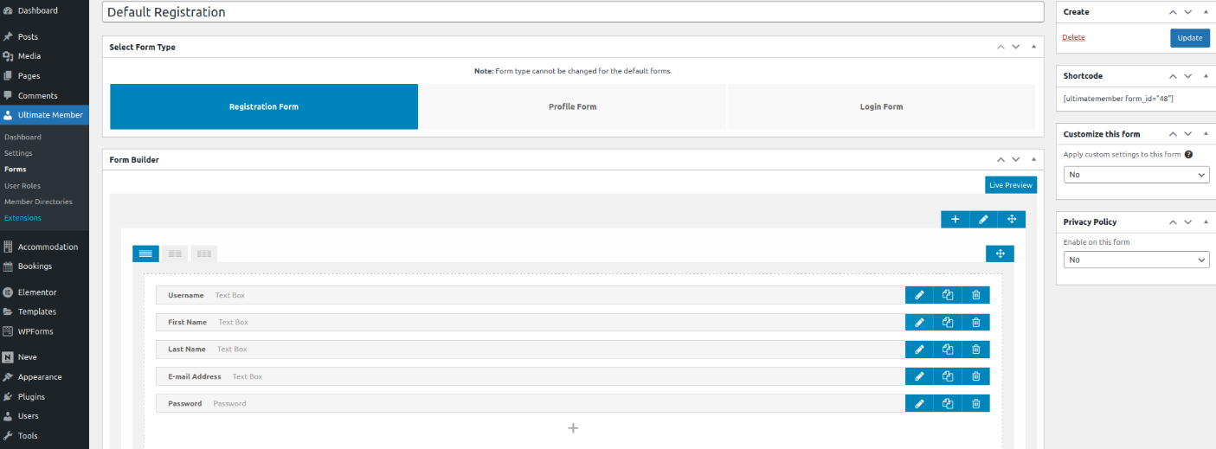*Figure 35: Editing registration forms*

The rules for registration can be edited by the administrator by opening the tab „Ultimate Member “, selecting the wanted form and making changes to it. To edit a single input field, the admin needs to click on the pencil icon of the respective field to make changes to it.

It is important to note, that the default roles of new accounts are „Hotel Customer “. This role has the most basic permission and can only navigate through the website and make bookings. To change this default role, the admin can do this in the settings tab of the plugin „Ultimate Member “. This can be seen in Figure 36.

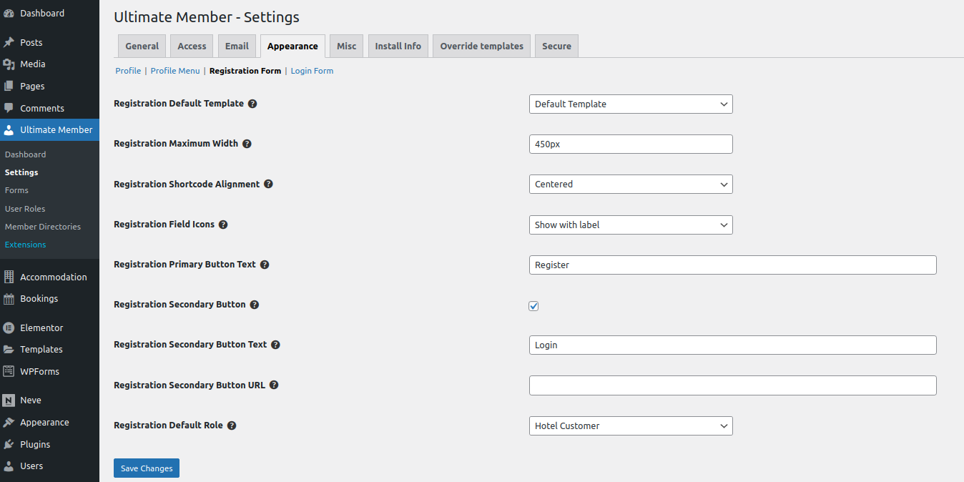

*Figure 36:* Changing the default registration role

## **4.3 Property Owner Role**

To generate, edit, publish and delete personal accommodations from the website, we created a new user role called „Property Owner “. This role cannot interfere with the settings of the website itself but can use the booking and property management utilities. Accounts with this role need to be created by the administrator manually. The credentials can then be sent to the homeowners.

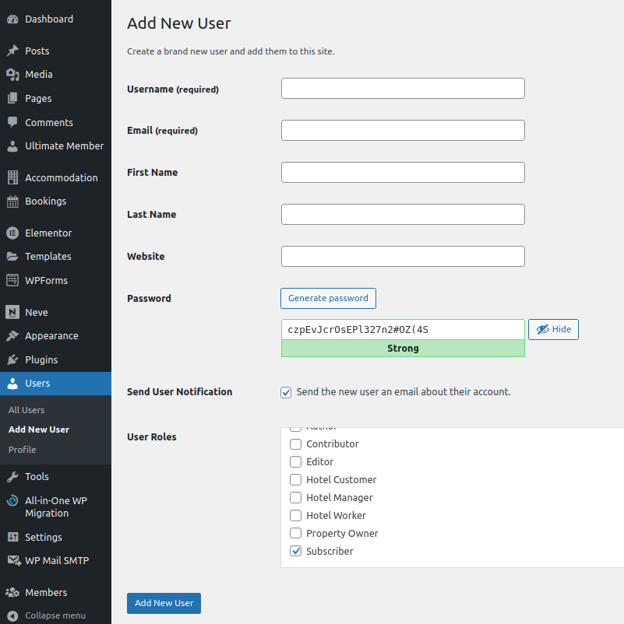

*Figure 37: Creating a property owner account*

To create this account, the administrator needs to navigate to the Users-tab, click on „Add new user “and fill in the required fields. It is important to set the correct role at the end. This can be seen in Figure 37.

Property owners can enter the WordPress dashboard but will have a very limited list of options. As can be seen in Figure 38, they and manage their accommodations and bookings, but cannot modify any other parts of the website.

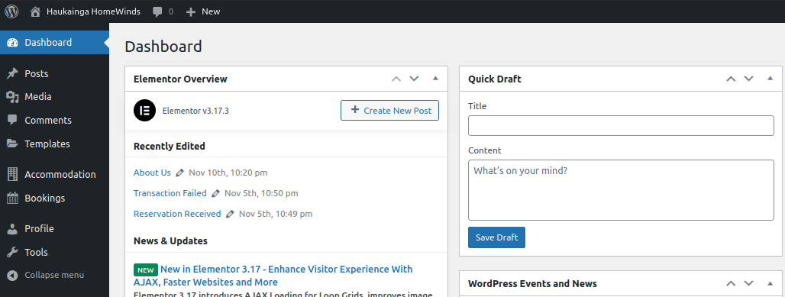*Figure 38: WordPress dashboard for property owners*

In case the administrator wants to change the capabilities of this (or any) role, this task can be done in the „Members “tab within WordPress.

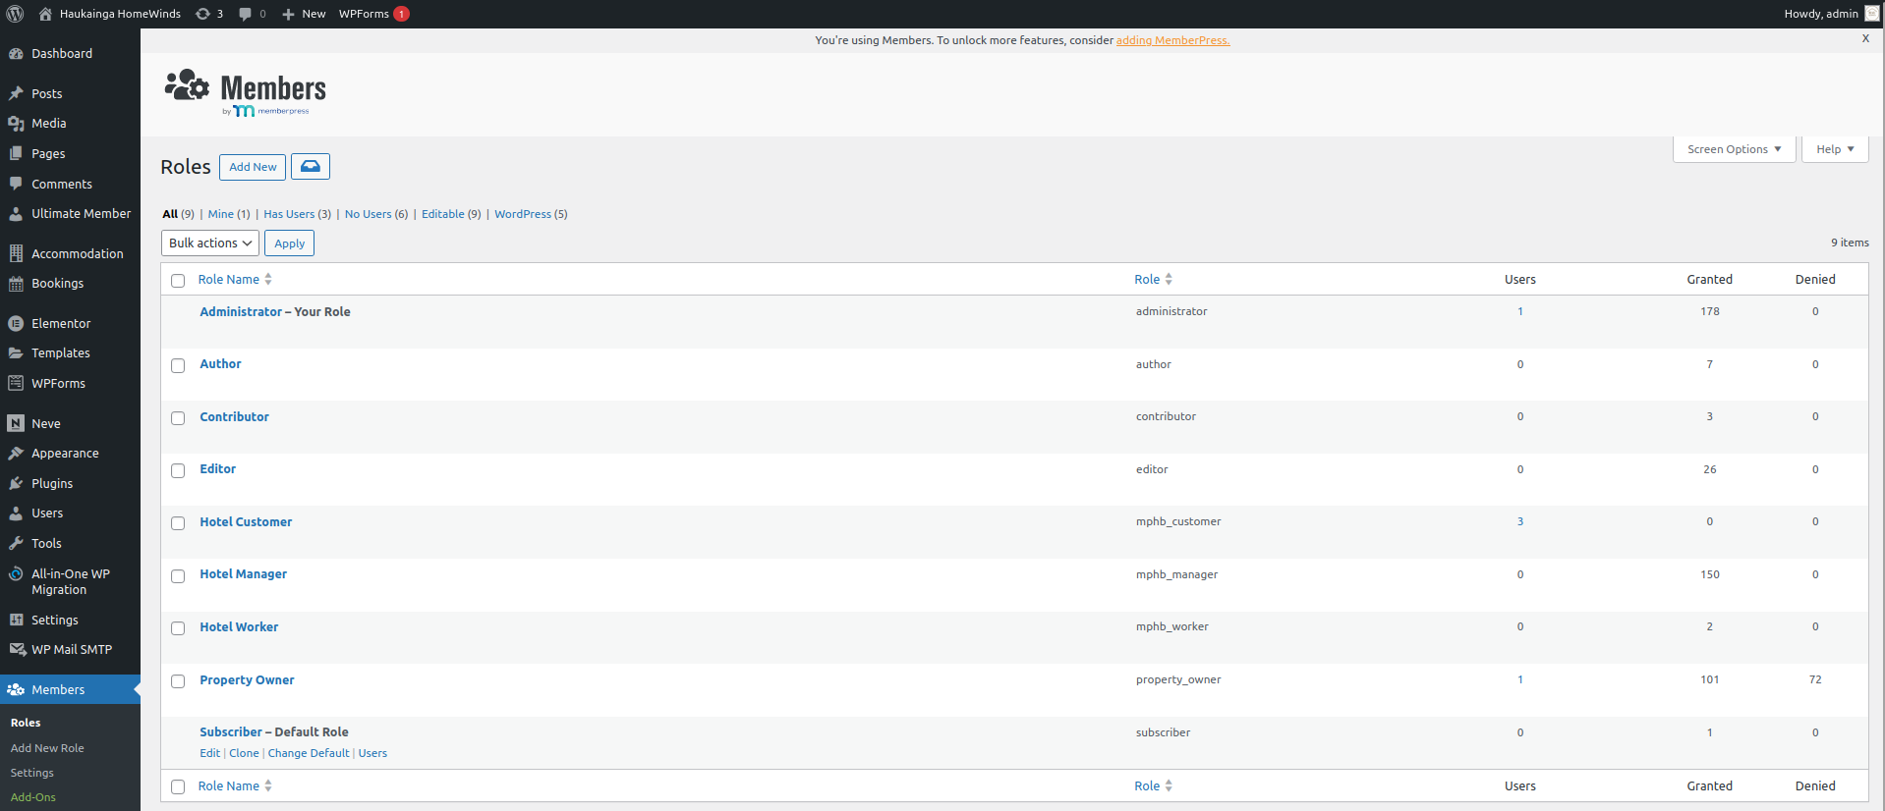*Figure 39: Changing capabilities of different roles*

By clicking on the edit button of any role, the selected role can be modified to have certain capabilities.

# **5 Additional Features**

## **5.1 WP Mail SMTP**

Navigate to WP Mail SMTP. To test the e-mail services of the Hotel Booking Plugin we used the WP Mail SMTP Plugin. The Plugin comes with a Setup Wizard and supports various mail service providers. We used a mail account at Google. To set up this feature please refer to the Plugin documentation and follow the instructions provided by the Setup Wizard.

To alter the e-mail notification of the Hotel Booking Plugin navigate to Accommodation/Settings and alter the E-Mail settings.

## **5.2 WP Forms**

Navigate to WP Forms. We are using the WP Forms Plugin to provide users to contact the site administrator (Figure 40). New Forms can be created and used as “Blocks” in the WordPress or Elementor Editor. Please refer to the Plugin documentation or hints when creating a new form.

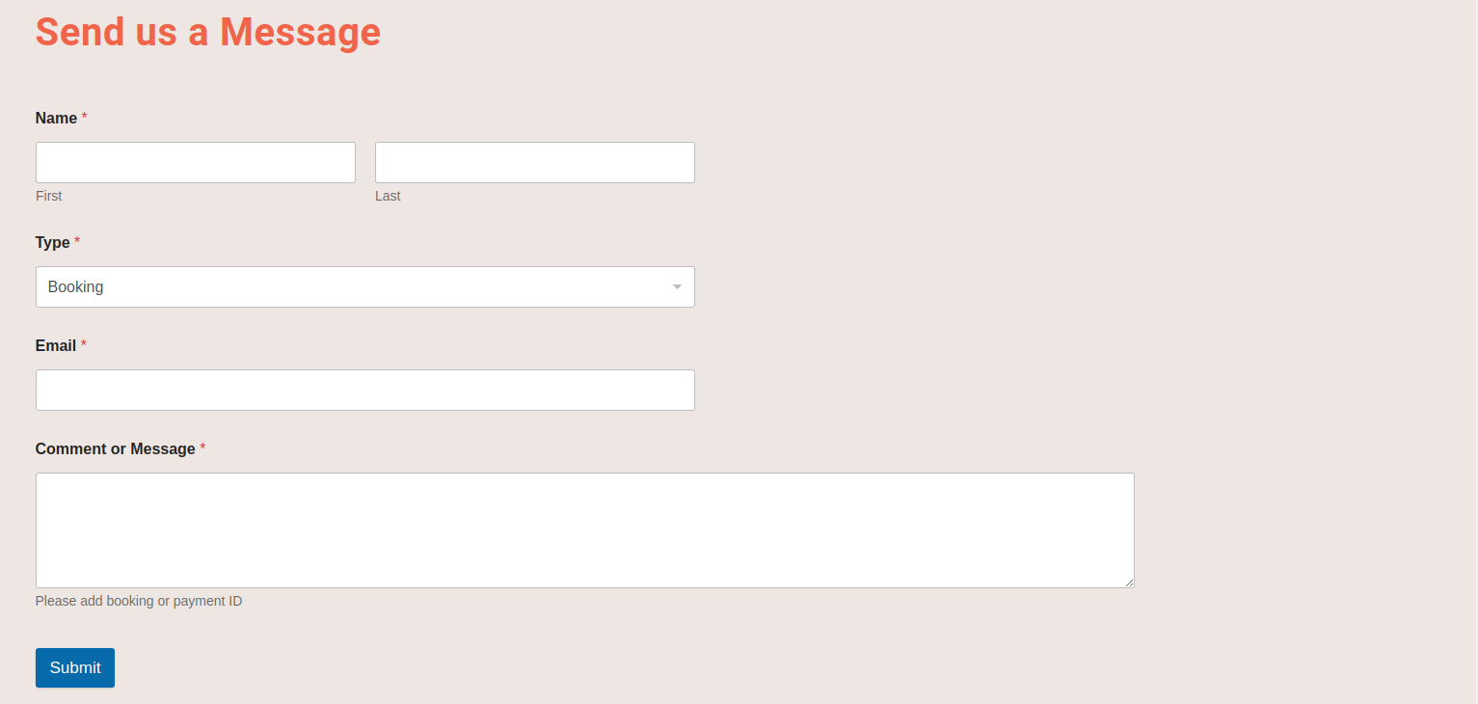

*Figure 40: Contact Form*

## **5.3 Sending Emails**

For Testing purposes, we used the plugin “WP Mail SMTP” to connect an external email service provider for sending all business-related emails. They offer a wide variety of email providers to choose from. In our Testing scenario we used google mail. The setup process is fast and easy. Tutorials are provided by the plugin to help during setup.

We would recommend choosing a hosting provider with email capabilities.

# **6 User Acceptance Testing**

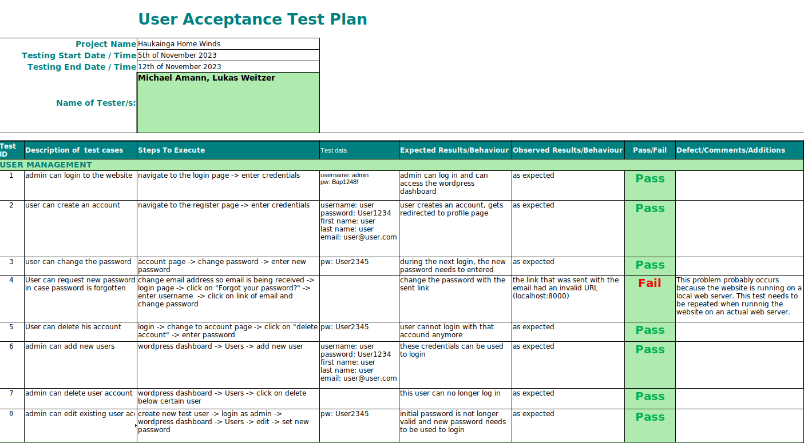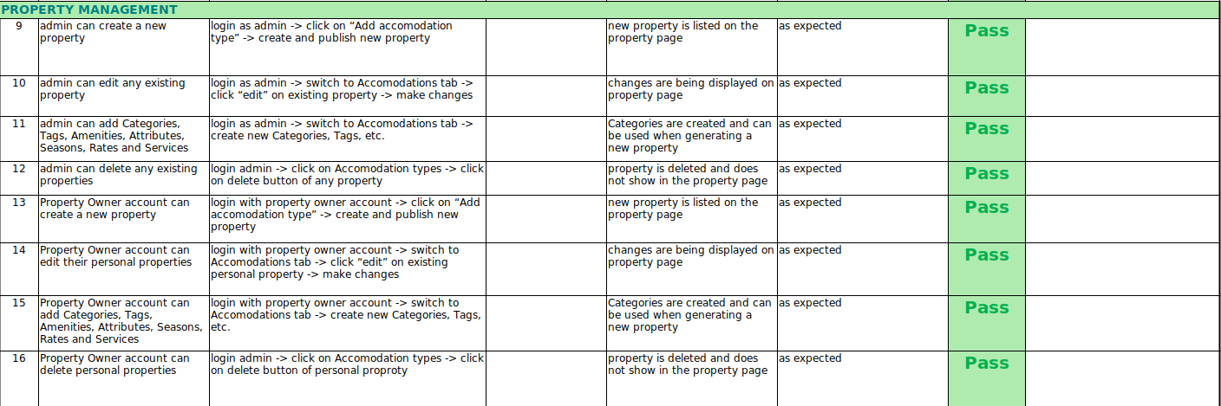

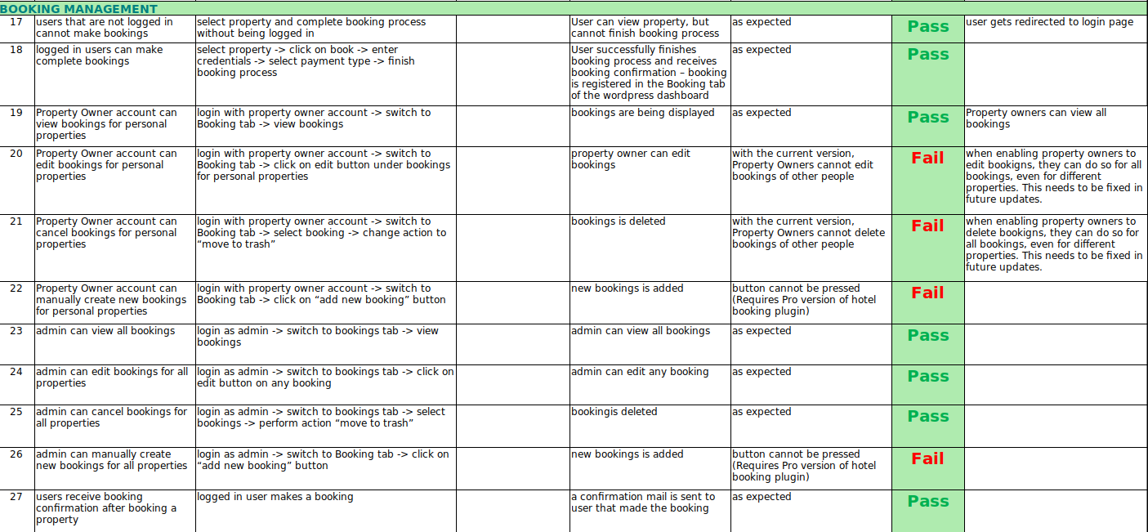

*Figure 41: User Acceptance Testing*